**Engineering Success: Mastering Risk Management In Product Design**

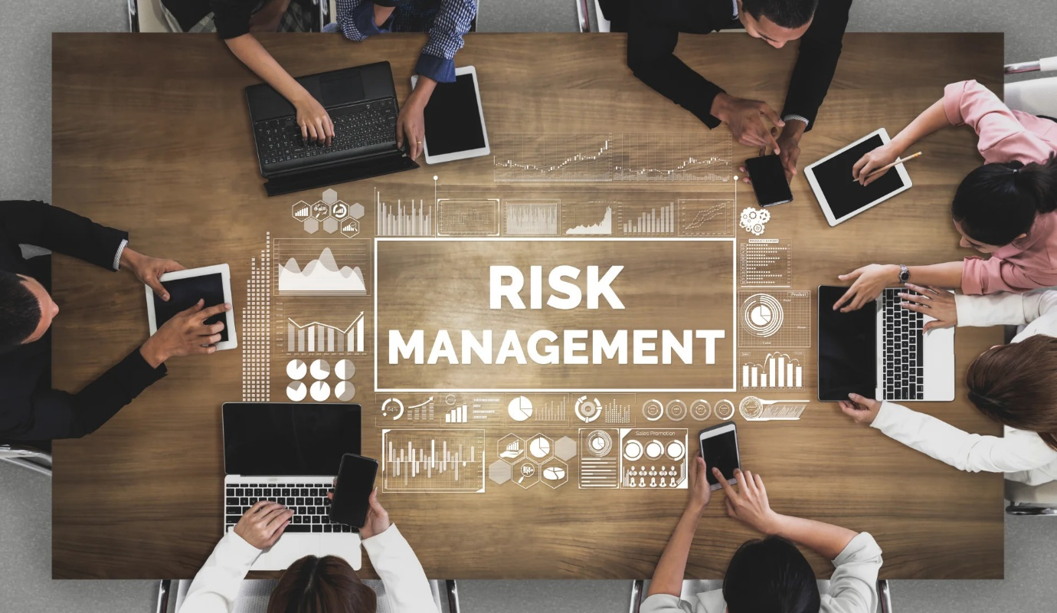

**Effective risk management in product engineering** is a vital discipline that identifies, analyzes, and mitigates potential risks throughout the development lifecycle. It safeguards against uncertainties that could disrupt timelines, inflate costs, or compromise quality. In a dynamic environment of technological advancements and evolving market demands, effective strategies anticipate and address diverse risks, turning them into opportunities for growth. Through exploration of best practices and real-life examples, readers gain insight into navigating product engineering uncertainties with confidence and foresight.

**Understanding Risks in Product Engineering**

Risks in product engineering are potential events or conditions that could hinder project objectives. They encompass various types, including technical, operational, market, and financial risks. Each type requires unique mitigation strategies.

**Defining Risks in Product Engineering**

Technical risks involve challenges with technology, such as software or hardware issues. Operational risks pertain to project execution processes and logistics. Market risks relate to external factors like market demand and competition. Financial risks involve budget constraints and return on investment considerations.

**The Impact of Risks on Projects**

Risks can substantially impact product engineering projects. Technical risks may cause development delays, while operational risks can lead to inefficiencies and increased costs. Market risks may result in products that do not meet user expectations, and financial risks could threaten project viability.

**Risk Assessment**

A Structured Approach: A structured approach to risk assessment is essential for identifying potential threats. This involves system characterization, threat identification, vulnerability identification, control analysis, likelihood determination, impact analysis, risk determination, and control recommendations. This process ensures a thorough understanding of risks and forms the basis for effective risk management strategies.

**Risk Identification in Product Engineering**

Early detection is crucial for effective risk management. Vigilance should begin at the conceptualization stage, involving thorough market analyses, feasibility studies, and technology assessments.

Understanding market trends and customer preferences is key. This entails analyzing competitors, identifying emerging market needs, and foreseeing shifts in consumer behavior.

Evaluating technical and operational feasibility is essential. This involves assessing available resources, technological capabilities, and logistical aspects to identify potential risks.

Assessing the suitability and scalability of technology is vital. This helps identify risks related to integration, scalability, and technological obsolescence.

Engaging with stakeholders provides diverse perspectives. Stakeholder feedback is crucial for identifying usability and customer experience-related risks.

Various tools aid in risk identification. SWOT analysis recognizes internal and external factors, while risk matrices categorize and prioritize risks based on likelihood and impact.

**Risk Analysis and Prioritization**

After identifying risks, analyzing their severity and likelihood is crucial. Qualitative methods, such as expert judgment, and quantitative methods, like probability distributions, aid in this assessment. Prioritizing risks based on impact on project objectives, probability of occurrence, time sensitivity, and resource availability ensures focused mitigation efforts. Developing a risk register facilitates ongoing monitoring and management of identified risks throughout the project lifecycle.

**Risk Mitigation Strategies in Product Engineering**

Once risks are identified and prioritized, the focus shifts to developing mitigation plans. Strategies include risk avoidance, altering plans to eliminate or protect from risk; risk reduction, implementing quality control measures; risk transfer, outsourcing, or purchasing insurance; risk acceptance, when mitigation costs outweigh benefits; and contingency planning, preparing for worst-case scenarios with budget reserves or alternative plans. These strategies aim to reduce the likelihood or minimize the impact of potential risks on project objectives.

**Risk Monitoring and Control**

In product engineering, effective risk management is a continual process involving ongoing monitoring and control. This includes regular tracking and reviewing of the risk register, establishing KPIs for risk management, maintaining open communication with stakeholders, and adjusting strategies as projects evolve. Feedback loops and post-project reviews provide valuable insights for future risk management endeavors, ensuring continual improvement in managing project risks.

**Integrating Risk Management into the Product Engineering Process**

Embedding risk management practices throughout the product lifecycle is essential for proactive risk handling. This involves fostering a risk-aware culture and incorporating risk management into every phase, from project planning to design, development, testing, and deployment. Leadership plays a crucial role in promoting risk awareness, while training programs ensure team members possess the necessary skills. Leveraging tools and technologies further enhances risk management efficiency, providing real-time data and analytics to inform decision-making and support all stakeholders.

**Learning from Risks: Post-Project Analysis**

Post-Project Analysis involves conducting thorough reviews focused on risk management effectiveness. This includes evaluating strategies, documenting lessons learned, and identifying areas for improvement. Insights gained from these reviews can be used to enhance future risk management practices, promote knowledge sharing, and foster a culture of continuous improvement within the organization. Effective risk management is vital for navigating the complexities of product engineering projects and ensuring their success.

**Conclusion**

Effective risk management in a **product engineering services company** is a continuous process integrated into every stage of development. It demands diligence, foresight, and adaptability, from identifying risks early to adjusting mitigation strategies. Key aspects include structured risk assessment, embedding risk practices into project phases, leadership's role in fostering a risk-aware culture, and leveraging advanced tools. Post-project reviews are crucial for learning and improvement, contributing to more successful outcomes and increased customer satisfaction in future projects.